8
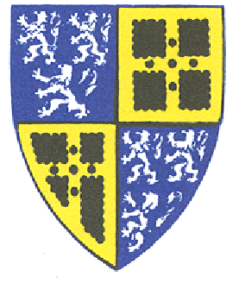
Town of Old Saybrook
Public Health Nursing Board
Town Hall, 302 Main Street,
Old Saybrook, CT 06475
_______________________________________________
Meeting Agenda
6:30pm, Tuesday, November 1, 2022
Via internet click this link
302 Main Street, Old Saybrook
Second Floor Conference Room
Via phone: (929) 436-2866 Meeting ID: 933 5220 5842
- Call to order and roll call
- Audience of citizens
- Review and approval of minutes
- Review and approval of treasurer’s report
- Correspondence report
- Old Business report
  - Monthly Report of VNASC Services
- New Business Report
  - Clerk time & task invoice approval
  - Hearing Aid Fund/Social Services Report
- Y&FS Representative Report
- Flanagan Fund Report
- Nightingale Fund Report
A. Discuss 2023 Nightingale Scholarship Letter (add quote)
- Morris Fund Report
- Adjournment
NEXT REGULAR MEETING

Tuesday, December 6, 2022 at 6:30
P
.
M
.

Via internet click this lin
k

Via phone: (929) 436-2866

Meeting ID: 933 5220 5842

